Maybank
Customer Engagement Platform (CEP) – CMS
Detailed Design Document (DDD)

Confidentiality Notice
This document contains proprietary information that is confidential to Malayan Banking Berhad (Maybank) and the Next-Gen App (NGA) Initiative. Unauthorized disclosure of this document, whether in full or in part, may result in material damage to Maybank. Written permission must be obtained prior to the disclosure of this document to any third party.
Any printed or photocopied version of this document is considered an uncontrolled copy. The original, approved electronic version is deemed the controlled copy.

TABLE OF CONTENTS
TABLE OF CONTENTS 3
1. Document Purpose & Scope 1
1.1 Document Purpose 1
1.2 Architectural Strategy 1
1.2.1 Contract-Driven Design 1
1.2.2 Global & Country Configuration 2
1.2.3 Architectural Principles 2
1.3 System and Boundaries Included (In-Scope) 2
1.3.1 CMS Platform 2
1.3.2 Content Models and Managed Structures 2
1.3.3 Contract Exposure Layer 3
1.3.4 Content Governance and Lifecycle 3
1.4 Out of Scope Clarifications 3
2. High-Level Architecture View 3
2.1 Component Diagram 3
2.2 Component Descriptions 4
2.2.1 Frontend Delivery Layer 4
2.2.2 CEP Domain 4
2.2.3 Other Domain Integrations 5
2.3 Microservices Listing 5
2.4 Key Design Patterns 6
3. Functional Design 7
3.1 Sequence Diagrams 7
3.1.1 Journey 7
3.1.2 Screen 8
3.1.3 Notification Template 9
3.1.4 Receipt Template 10
3.1.5 Manifest 10
3.1.6 Webhook 11
3.2 Content Configuration 11
3.2.1 Configurable Content Types 11
3.3 Content Lifecycle 12
3.3.1 Change Classification 12
3.4 Versioning Strategy 13
3.5 Locationisation Strategy 13
3.6 Payload Projection 13
3.7 Governance 14
3.7.1 Role-Based Access Control 14
3.7.1.1 Viewer 14
3.7.1.2 Editor 14
3.7.1.3 Reviewer (Publisher) 15
3.7.1.4 Super Admin 15
3.7.2 SOPs 15
3.7.2.1 Base Principles 16
3.7.2.1.1 No Sensitive Data Storage 16
3.7.2.1.2 Clear Ownership Boundaries 16
3.7.2.1.3 Version Control 16
3.7.2.2 Naming Conventions 16
3.7.2.2.1 Content Naming 16
3.7.2.2.2 Content Field Naming 17
3.7.2.2.3 ID Field Values 17
4. API Design 18
4.1 API Principles 18
4.2 API Endpoint & Design Specification 19
5. Data Design 19
5.1 Logical Data Model 19
5.2 Data Flow Diagrams 21
5.2.1 Static Content Data Flow 21
5.2.1.1 L1 21
5.2.1.2 L2 22
5.2.2 Dynamic Content Data Flow 23
5.2.3 Hybrid Content Data Flow 24
5.3 Caching Strategy 25
6. Appendix 25
6.1 Glossary of Terms 25

Revision History
Version | Effective Date | Summary of Changes
1.0.0 | 29/04/26 | Initial Release
1.0.1 | 30/04/26 | Correct minor mistake
1.1.0 | 04/08/26 | Realigned the content model, API and governance sections to the as-built implementation. Removed the module, modal and component/dynamic-zone model. Added navigator, stp-screen, media-asset and the Product Catalog (product-group, product-category, product). Added the webhook payload contract and the CMS to MBPNS notification-template push. Rewrote Payload Projection and the ID Field Values SOP to match implementation. Marked Manifest and ETag-based caching as not yet implemented.

Prepared By
Name | Project Role
Daniel Pearson | Senior Consultant
Raihan Al Bazzy | Consultant
Yudhi Hermanwan | Consultant

Stage 1: Reviews the validity and accuracy of the High / Low Level Design
Reviewed By
Name | Department | Project Role | Section | Signature | Date
Dendy Aryaga |  | Delivery Lead

Stage 2: (a) Approves and supports the reviewed scope of work raised for project
(b) Agrees to the proposed changes and enhancements to the system
Approved By
Name | Department | Project Role | Section | Signature | Date

Document Purpose & Scope

Document Purpose
This document defines the principles, responsibilities and detailed technical design required to implement the integration model between the CMS domain, downstream domain services and the NextGen Mobile Application (NGA).
Its purpose is to:
- Establish a shared understanding of system responsibilities
- Define ownership boundaries across CMS, domain services and NGA
- Define the types of content and configuration managed in CMS
- Clarify API contract expectations
- Detail any enhancements required on top of the base CMS system
- Prevent ambiguity in integration patterns
- Serve as a baseline for future enhancements
It provides:
- API specifications, including request/response schemas, versioning and error handling
- Data contracts and payload structures
- Content modelling definitions
- Integration sequence flows and interaction patterns
- Caching behaviour
- Configuration requirements
- Localisation handling strategy
- Content versioning strategy
- Content governance and lifecycle
The level of detail provided is sufficient for engineering teams to implement the solution without architectural ambiguity.

Architectural Strategy
The architecture is built around contract-driven integration, where CMS acts as the authoritative source for structured content consumed by multiple systems.

Contract-Driven Design
- CMS exposes content and configuration through defined provider contracts aligned to consuming applications and services.
- Content models are designed from the required output structure and consumer retrieval pattern first.
- Contracts are shaped to be consumer friendly, stable and implementation ready.
- CMS owns the structure and publication of contracts while consuming systems own how they interpret and execute them.

Global & Country Configuration
- CMS supports the separation of globally reusable content from country specific configuration.
- Global definitions are created once and reused where no market level variation is required.
- Country specific content is managed as an explicit variation layer, not as ad hoc duplication.
- Localisation and market differences are controlled through governed configuration structures.
- The contract delivered to consumers must resolve to the correct market specific version for the requested context.

Architectural Principles
- CMS is the single source of truth for presentation-oriented content and non-executable configuration metadata.
- Execution logic remains in domain services.
- No runtime decision logic is executed in CMS.
- Each contract type is versioned independently.
- Contracts are strictly typed and schema defined.

System and Boundaries Included (In-Scope)
The CMS domain is responsible for the following capabilities:

CMS Platform
Headless CMS capabilities including content modelling, content storage, administrative interfaces, API exposure, role-based access control and lifecycle management for managed content.
Additionally, the storage and retrieval of structured content, metadata, localisation variants and versioned records required for downstream consumption.

Content Models and Managed Structures
Content structures used to define screen-level content and component-level content for frontend or downstream screen rendering use cases.
Structured notification templates managed in CMS and exposed for downstream consumption by the MBPNS notification service.
Reusable content entities such as labels, messages, help text, banners, media references and other common content elements intended for reuse across multiple content records.
Localisation of text content for use in respective markets.

Contract Exposure Layer
CMS owned APIs that expose consumer optimised payloads for downstream systems based on approved content structures and retrieval patterns.
Content projection logic which handles content manipulation logic required to assemble CMS managed records into stable contract responses expected by consuming applications and services.

Content Governance and Lifecycle
Content workflow management lifecycle including draft, review, approval and publish lifecycle states for content before release to consuming systems.
Mechanisms and rules for maintaining versioned content, assessing backward compatibility and supporting controlled contract evolution.

Out of Scope Clarifications
Frontend / Channel Applications: The design and implementation of consuming frontend channels, including NGA MFE, mobile applications and web portals are out of scope. These channels consume CMS exposed content contracts but are not part of the CMS component design.
Downstream Domain Logic: The internal logic of downstream systems such as STP, MBPNS and other domain services is out of scope. These systems are treated as consuming dependencies that retrieve and process CMS managed content according to their own domain rules.
Business Process Orchestration: Runtime journey execution, transaction processing, decisioning logic and backend orchestration behaviour are out of scope. The CMS is responsible for storing and exposing configured content and structured definitions but not for executing business flows.

High-Level Architecture View

Component Diagram
The NGA Mobile App consumes CMS-managed content through Akamai CDN, which provides the frontend delivery path for cached and secured content access. All frontend requests to Strapi CMS are routed through Akamai.
Strapi CMS is hosted within the CEP domain and acts as the central provider for screen, navigation, template, media and product catalog content. CMS content is persisted in the CMS database and exposed through structured APIs.
Within the CEP domain, STP retrieves STP screen content from Strapi CMS. MBPNS retrieves notification templates and related content for customer communications, and additionally receives notification-template changes pushed from Strapi CMS.
P&T and ECLIPSE integrate with Strapi CMS through internal service-to-service API calls. These backend integrations do not route through Akamai.
For content consumed by other domains, content is required to be cached into Hazelcast by the respective domains. Strapi CMS will provide a webhook to notify respective domain of content updates.
This design separates frontend content delivery from backend service integration. Strapi CMS remains the content provider, while orchestration, runtime execution and business logic remain owned by the respective consuming systems.
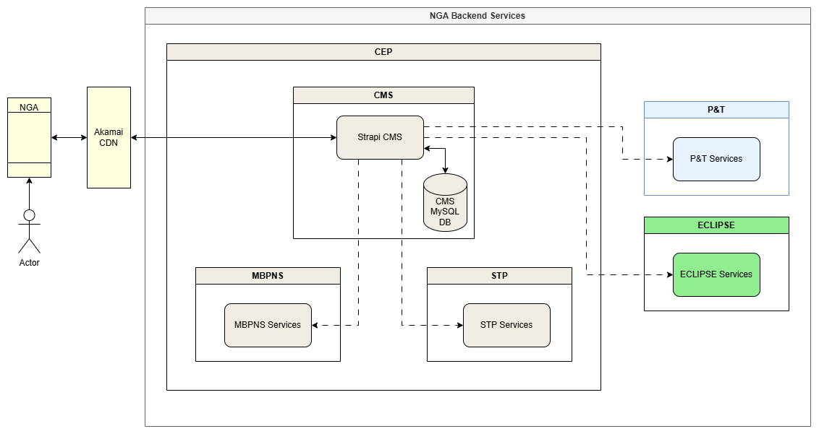

Component Descriptions

Frontend Delivery Layer
Defines the controlled frontend access path for NGA Mobile to retrieve CMS-managed content.
NGA Mobile App
The NGA Mobile App is the frontend client that consumes CMS-managed content for journeys, screens and related UI content. It does not call Strapi CMS directly.
Akamai CDN
Akamai CDN provides the public delivery path between NGA Mobile and Strapi CMS. It handles frontend traffic routing, caching and secured content delivery before forwarding valid requests to Strapi CMS.

CEP Domain
Defines the internal domain boundary where Strapi CMS, STP and MBPNS are hosted.

Strapi CMS
Strapi CMS is hosted within the CEP domain and acts as the central provider for CMS-managed content. It exposes structured APIs for screen and STP screen content, sub-journey navigation, notification templates, receipt templates, media assets, the product catalog, localisation content and Help & Support configuration.
Strapi CMS provides content only. It does not execute journeys, perform orchestration, process transactions or own business logic.
CMS MySQL Database
The CMS database stores Strapi CMS content, metadata, versions and publishing state. Strapi CMS is the only component that can directly access this database. The database client is selected through the DATABASE_CLIENT environment variable: deployed environments use MySQL, while local development defaults to SQLite.
STP Services
STP Services integrate with Strapi CMS to retrieve screen content required for STP-driven flows. Runtime journey execution and business processing remain owned by STP.
MBPNS Services
MBPNS Services integrate with Strapi CMS to retrieve notification templates and related content used for customer communications. Strapi CMS additionally pushes notification-template create, update and delete events directly to MBPNS as described in section 3.1.3, making this integration bidirectional. Notification delivery and runtime notification processing remain owned by MBPNS.

Other Domain Integrations
Defines backend domains that consume CMS-managed content through internal service-to-service integration.
P&T Services
P&T Services integrate with Strapi CMS to retrieve CMS-managed content or configuration required by payment and transfer journeys. These backend integrations do not route through Akamai.
ECLIPSE Services
ECLIPSE Services integrate with Strapi CMS to retrieve CMS-managed content or configuration required by ECLIPSE domain services. These backend integrations do not route through Akamai.

Microservices Listing
Microservices naming convention will be split product-wise, top-down and suffixed by region.
CEP associated microservices follow the naming pattern:
cep-<category>-<country_code>
Where:
- <category> = Functional domain of the microservice
- <country_code> = Supported country codes (id, sg, my, ph, kh)
CEP
Category | Name | Remark
CMS | cep-cms-<country_code> | Provides static content

Key Design Patterns
Centralise business-managed content: Strapi CMS is the authoritative source for structured content such as labels, banners, screen content, navigation sequences, notification and receipt templates, media references, product catalog data and configuration metadata.
Decouple content from code: content changes should be managed independently from mobile app releases or backend deployments, reducing dependency on engineering for routine updates.
Enable governed business ownership: business and content teams can manage approved content, while engineering defines the content models, API contracts, validation rules and integration boundaries.
Support content localisation: Strapi CMS should support multiple languages without embedding localisation logic in application services.
Intelligent content configuration patterns: content should be configured in such a way that changes to common language / text used can happen easily and rapidly.
Expose content through structured APIs: content should be consumed through governed, versioned APIs rather than direct database access or unmanaged retrieval patterns.
Separate content from runtime logic: Strapi CMS owns content storage and delivery only. Rendering, orchestration, runtime decisioning, transaction processing and business logic remain with the consuming systems.
Control publishing and versioning: content should follow a managed lifecycle for review, approval, publishing, rollback and auditability.

Functional Design

Sequence Diagrams

Journey


Screen


Notification Template
Note: the diagram shows MBPNS retrieving templates from CMS. In addition to that pull path, CMS now actively pushes notification-template changes to MBPNS. On create it issues POST, on update PUT, and on delete PUT to the /soft-delete path, all against the NOTIFICATION_TEMPLATE_API_URL endpoint. Unlike the generic webhook this call carries the full entry rather than a hash, and it fires independently of WEBHOOK_URL. Failures are logged and do not roll back the CMS write, so MBPNS must tolerate missed pushes and reconcile through the pull path. The diagram should be redrawn to show this push leg.

Receipt Template
No sequence diagram has been produced for this flow yet. The behaviour is a straightforward versioned lookup.
GET /api/receipt-templates returns the published receipt templates. GET /api/receipt-templates/{receiptTemplateId} returns the single highest version record for that receiptTemplateId, sorted by version descending, and responds 404 when no published record exists. Both routes are unauthenticated, consistent with the other CMS delivery endpoints.

Manifest
Status: not yet implemented. The design below is retained as the agreed target. There is currently no /manifest route in the CMS, and no ETag, If-None-Match or Cache-Control handling in the codebase. The sequence shown is the intended behaviour once the manifest endpoint and the ETag caching strategy in section 5.3 are built.


Webhook
Strapi CMS emits a webhook after every create, update, publish, unpublish and delete on any document. The emitting middleware is registered at bootstrap and applies to all content types.
The payload is deliberately slim. It carries the event name, the content type uid, and whichever of version, updatedBy, updatedAt, moduleName and locale are present on the record. Every field whose name ends in Id - screenId, mediaId, subJourneyId and so on - is detected automatically and included, so a new collection needs no webhook configuration. The record itself is not transmitted: the entry field carries a SHA-256 hash of the full Strapi entry, which consumers use to detect change without CMS exposing content over the webhook channel.
Consumers must therefore treat the webhook as a change signal only, and re-fetch the content through the normal CMS API. This is consistent with the API principle that webhooks are not a runtime content delivery mechanism.
The default target is the WEBHOOK_URL environment variable. Per content type overrides are configured in WEBHOOK_UID_CONFIG, and content types that should emit nothing are listed in WEBHOOK_EXCLUDED_UIDS.
Two de-duplication guards, each with a two second window, prevent spurious emissions. The first suppresses the update event that Strapi raises internally immediately after a create. The second suppresses repeat emissions of the same event, documentId and locale combination. Consumers should still be idempotent, as the guards are in-process and do not survive a restart or span multiple instances.

Content Configuration
For a detailed specification of each content configured in Strapi CMS, please refer to CEP_CMS_DDD_Configuration_Design_v1.0.xlsx

Configurable Content Types
Content | Type | Description
screen | Collection Type | Versioned screen content for standard (non-STP) journeys. Keyed by journeyId, screenId and version. The components field is plain JSON authored directly in the CMS.
stp-screen | Collection Type | Versioned screen content for Straight-Through Processing flows, consumed by STP Services. Keyed by screenId and version; components is plain JSON.
navigator | Collection Type | Ordered screen sequence for a sub-journey. Keyed by subJourneyId (unique); screens is a plain JSON array of screenCode, screenName and sequence entries.
notification-template | Collection Type | A versioned record of a notification template used by MBPNS, covering two push variants, web inbox, email and SMS. templateId is generated server-side as a UUID v4.
receipt-template | Collection Type | A versioned record of a receipt template used by the Receipt Library. Keyed by receiptTemplateId and version.
media-asset | Collection Type | Media reference sets keyed by mediaId (unique). The list field is plain JSON and is merged with mediaId in the API response.
product-group | Collection Type | First tier of the Product Catalog. Keyed by screenId and moduleId; groups is a plain JSON array returned sorted by displayOrder.
product-category | Collection Type | Second tier of the Product Catalog. Keyed by productGroupCode (unique); categories is a plain JSON array returned sorted by displayOrder.
product | Collection Type | Third tier of the Product Catalog. Keyed by productGroupCode and productCategoryCode; data holds the aggregated products payload.
i18n-key | Collection Type | A registry of internationalisation keys that can be referenced from any content.
i18n-content | Collection Type | Localised JSON content keyed by moduleId, locale and version. Ingested through the POST /api/i18n-content-upload endpoint rather than the admin UI.
security-image | Collection Type | A collection of security image filenames, served as CDN_URL/security-images/filename.
help-support-setting | Single Type | Stores localised Help & Support screen content: contact numbers, guide link, and about/legal policy URLs. contacts, guide and about are plain JSON fields. One published record per locale.

help-support-setting is the only Single Type in the CMS content model. Unlike Collection Types, a Single Type holds exactly one record per locale, so there is no identifier and version compound key. Versioning is not applicable; updates are made in place and published directly.
Note on i18n-content ingestion: Translation content is loaded into the i18n-content collection via the POST /api/i18n-content-upload endpoint rather than through the admin UI. This endpoint accepts multipart .json files named _.json and auto-increments the version on each upload.

Product Catalog
The product catalog is modelled as three collections that form a cascade: product-group, then product-category, then product. They are joined by code values carried in string fields rather than by Strapi relations, which keeps each tier independently publishable and lets downstream consumers request a single tier without traversing the graph.
product-group is keyed by screenId and moduleId, and its groups JSON array defines the product groups shown on that screen. product-category is keyed by productGroupCode, which is unique, and its categories JSON array holds the categories belonging to that group. product is keyed by the productGroupCode and productCategoryCode pair, and its data JSON field holds the aggregated product payload for that combination. Every array is returned sorted by displayOrder.
Because the joins are by code rather than by relation, the CMS enforces no referential integrity between the tiers. Consistency is maintained at authoring time instead: the productGroupCode and productCategoryCode fields are custom fields that render as searchable dropdowns in the admin, populated from GET /api/product-groups/codes and GET /api/product-categories/codes so an editor selects an existing code rather than typing one. This is a governance control rather than a technical constraint, and it does not prevent a code from being orphaned if the tier above it is later edited or unpublished.
The delivery endpoints follow the same pattern in each tier: supplying the full key returns a single record, while supplying a partial key or no key returns the matching set. GET /api/aggregated-products returns one entry's data payload verbatim when both product codes are supplied, and otherwise merges the products arrays across every published entry. GET /api/products/{productId} searches inside each entry's data payload and returns the first matching product item.

Content Lifecycle
All CMS content must follow a controlled lifecycle to ensure structural integxrity and contract stability across consuming systems.
The standard lifecycle is:
- Draft
- Review
- Approval
- Publish
The level of review required is determined by the impact of the change.

Change Classification
Below is a classification of changes to content in the CMS and the processes to follow when such a change occurs.
Minor Changes consist of:
- Textual corrections
- Non-structural content updates
- Localisation updates
May follow streamlined review procedures.
Structural Changes consist of:
- Addition or modification of content fields
- Changes to component structure
- Changes affecting API response structure
Require domain review and compatibility validation prior to publication.
Breaking Changes consist of:
- Removal of required fields
- Renaming of content keys
- Structural modifications affecting existing consumers
And require:
- Contract version increment
- Explicit consumer alignment
- Impact assessment documentation
Content updates must not introduce:
- Unreviewed structural modifications
- Key renaming without consumer alignment
- Removal of required configuration elements without impact analysis
This lifecycle model ensures that CMS remains a stable configuration authority and does not introduce unintended downstream system impact.

Versioning Strategy
Content that requires versioning is configured as a Collection Type with an integer field named version. Versioning is applied selectively rather than universally, because not every content type is consumed in a version-aware way.
The versioned collections are screen, stp-screen, notification-template, receipt-template and i18n-content. The collections navigator, media-asset, product-group, product-category, product, i18n-key and security-image carry no version field and are updated in place, as is the help-support-setting Single Type. Where a collection is versioned, the delivery endpoint that looks a record up by its identifier returns the highest published version.
When a new version of versioned content is required, a new record must be created with an incremented version number rather than overwriting the existing published record. Strapi's Draft & Publish lifecycle governs release of each record, and all delivery endpoints read published records only. Note that the display-name convention of contentId v version described in earlier revisions of this document is not implemented; records are identified in the admin by their identifier and version fields directly.

Locationisation Strategy
Each supported language is configured in Strapi, allowing content records to be maintained and delivered per locale. Localised content may be managed directly on the relevant content records where the text is specific to a screen or template. For common or repeated text, the i18n-key Collection Type stores reusable labels, messages, button text, error text and other shared copy, so common wording can be updated centrally instead of being duplicated across content configurations.
The translated payloads themselves are held in the i18n-content Collection Type, which is localised through the Strapi i18n plugin and keyed by moduleId, locale and version. Content is loaded through the POST /api/i18n-content-upload endpoint rather than the admin UI: the endpoint accepts multipart JSON files named moduleId_locale.json, auto-increments version on each upload, and rejects payloads that fail an XSS safety check before writing.
Retrieval collapses the per-locale records for the caller. GET /api/i18n-contents accepts moduleId as a query shorthand, and when no specific locale is requested - or when locale=all is passed - the response is returned keyed by every configured locale, with the locale list echoed in the response metadata. Requesting an explicit locale returns Strapi's standard single-locale response.
help-support-setting is also localised, holding one published record per locale.

Payload Projection
Consumers must not be exposed to the internal Strapi record shape. Where the stored shape and the contract shape differ, the CMS reshapes the record inside the collection's controller before returning it. Projection is therefore a controller concern; there are no dedicated projection services in the implementation.
Most collections need no projection at all and return the stored entity unchanged, because the JSON fields are already authored in the exact shape the consumer expects. Only five controllers reshape their output: product merges the products arrays across matching entries and sorts them by product.displayOrder; product-category and product-group flatten their JSON arrays, de-duplicate the code lookups used by the admin dropdowns, and sort by displayOrder; media-asset merges mediaId into the list payload; and i18n-content groups results per locale and accepts a moduleId query shorthand.
const products = results
.flatMap((entry) => entry.data?.products ?? [])
.sort(byProductDisplayOrder);

This keeps the reshaping logic next to the route that owns it and avoids a service layer that would exist only to forward calls. Because the delivery contract lives in the authored JSON rather than in code, adding a field to a screen, template or overlay payload requires no schema change, no controller change and no deployment.

Governance
The CMS domain enforces governance standards to ensure content consistency, security, and operational reliability across all consuming systems.
CMS governance applies to all content types.

Role-Based Access Control
To ensure proper governance, accountability, and controlled access to CMS resources, a Role-Based Access Control (RBAC) strategy will be implemented within the CMS. RBAC enables the system to assign permissions based on predefined roles, ensuring that users can only perform actions aligned with their responsibilities.
This approach helps enforce separation of duties, minimizes the risk of unauthorized content modifications, and supports a structured content governance workflow.
The CMS will implement four primary roles, each with different levels of access and responsibility within the content lifecycle.

Viewer
The viewer role is intended for users who require read-only access to the CMS content.
This role is for stakeholders, QA business users, or content observers who need visibility into CMS entries but must not change anything.
Strapi configuration permissions should be limited to:
- Collection Types: read
- Single Types: read
- No create, update, delete, and publish
- No Access to Settings
- No Access to role administration
- No Access to plugin configuration unless explicitly needed for read-only visibility
This role ensures transparency without operational risk. Users can inspect content status and existing entries but cannot alter workflow outcomes.

Editor
The Editor role is responsible for creating and updating content within the CMS. Editors are typically content creators or operational users who manage content entries.
Strapi configuration permission should include:
- Collection Types: read, create, update
- Single Types: read, update
- Draft save capability through normal content editing
- No permission to manage roles or settings
- No permission to publish or unpublish production content
Because Draft & Publish separates editing from publishing, Editors can work on draft content without pushing it live immediately.
This role supports content preparation while preventing unauthorized release. Editors can contribute content, but final control remains outside their scope.

Reviewer (Publisher)
The Reviewer (Publisher) role is responsible for validating content and approving it for publication. This role ensures that all published content meets the required quality, compliance, and governance standards.
Strapi configuration permission should include:
- Collection Types: read, update, publish
- Single Types: read, update, publish
- Limited edit capability for minor corrections
- No access to role administration
- No access to core CMS settings unless specifically required
This role becomes the formal publishing gate. If enforces separation of duties by ensuring that the same role that creates content is not necessarily the role that releases it.

Super Admin
The Super Admin role will be retained as the highest privilege administrative role in Strapi. This role is for platform owners or technical administrators responsible for system-level governance.
Strapi configuration permission should include:
- Full access to all Collection Types
- Full access to all Collection Types
- Full access to all Plugins
- Full access to all Settings
- User and role management
- Permission governance
- Environment/platform administration
This Super Admin role can access all features and settings, provides administrative oversight. But should be tightly restricted because it can bypass normal governance controls.

SOPs
A set of governance SOPs are categorised and described below:

Base Principles
The following foundational principles apply to all CMS-managed content:

No Sensitive Data Storage
No private, confidential or sensitive customer data shall be stored in the CMS.
The CMS is a configuration and content platform and is not designed for secure transactional data storage. Specifically, the CMS must not store:
- Customer personal data (PII)
- Account numbers
- Authentication credentials
- Transaction data
- Financial balances
- Runtime-generated data
CMS content must be limited to:
- Static UI content
- Structural configuration
- Template definitions
- Controlled enumerations
- Non-sensitive reference data
All runtime data must be retrieved from domain services.

Clear Ownership Boundaries
- CMS owns content storage, versioning, and governance
- Consuming domains own schema definition and semantic correctness
- CMS does not validate business logic
- CMS does not determine runtime behaviour

Version Control
All publishable content must be version-controlled. Breaking structural changes must follow agreed contract versioning strategy.

Naming Conventions
To ensure consistency across systems, Strapi naming must follow three conventions:
- Content naming must use kebab-case
- Content field naming must use camelCase
- Data values in ID-related fields must use snake_case

Content Naming
Content names and human-readable content configuration names must use kebab-case to be compliant with API design standards.
This applies to any collection or single type content configuration made within Strapi
Correct examples:
- notification-template
- module
- receipt-template
- screen
- common-text
Incorrect examples:
- notificationTemplate
- ReceiptTemplate
- common_text

Content Field Naming
Fields within content records must use camelCase
This applies to:
- Content type fields
- Component fields
- Nested JSON object fields
- API response field names
- Metadata fields
- ID-related field names
Correct examples:
- screenTitle
- helpText
- primaryButtonLabel
- errorMessageTemplate
- displayOrder
- dataBindingKey
- moduleId
- screenId
- subJourneyId
- productGroupCode
Incorrect examples:
- Screen_Title
- help-text
- primary_button_label
- ErrorMessage
- display-order
- module_id
- screen-id

ID Field Values
ID-related field names use camelCase, as above. The values stored inside those fields are not free-form: each family of identifier has its own fixed convention, and the convention is part of the consumer contract.
Journey, sub-journey and screen identifiers use upper snake case, for example APPLY_CC and SCR_CC_EKTP. Screen identifiers are additionally prefixed SCR_ so they are recognisable out of context. Product catalog codes use a short uppercase letter prefix followed by a zero-padded sequence, PG for a group and PC for a category, giving values such as PG001 and PC001. Module identifiers use camelCase, matching the module names used by NGA. The templateId of a notification-template is not authored at all: it is generated server-side as a UUID v4 on first save, is hidden in the admin during creation, and is read-only thereafter.
The screenName values carried inside a navigator record are a separate case again. They are PascalCase because they name the NGA screen component rather than a CMS record, and must match the component name the application registers.
This applies to:
- moduleId - camelCase
- journeyId and screenId - upper snake case, screen values prefixed SCR_
- subJourneyId - upper snake case
- productGroupCode and productCategoryCode - PG or PC prefix plus sequence
- templateId - generated UUID v4, never authored
- mediaId and receiptTemplateId - stable identifier chosen by the owning team
Correct examples:
{
"journeyId": "APPLY_CC",
"screenId": "SCR_CC_EKTP",
"subJourneyId": "APPLY_CC",
"productGroupCode": "PG001",
"templateId": "3f2a7c14-9e5b-4d81-a6f0-77c1b0e5d2aa"
}

Incorrect examples:
{
"journeyId": "apply-cc",
"screenId": "scrCcEktp",
"subJourneyId": "Apply_CC",
"productGroupCode": "pg 001",
"templateId": "payment_success_notification"
}

Naming must be descriptive, concise, stable and free from environment-specific references.
Content names, field names and ID values form part of the consumer contract. They must not be renamed after publication without version control and impact assessment.

Custom Fields and Admin Customisations
Four custom fields extend the Strapi admin. Each stores an ordinary string, so the data model and the API contract are unaffected; only the authoring experience changes. They are registered on the server so the schema resolves, and again in the admin application so the input component loads.
templateId on notification-template is hidden while a record is being created, because the value is generated server-side, and is shown read-only once the record exists. parentLanguageId defaults to the locale selected in the content manager. productGroupCode and productCategoryCode render as searchable dropdowns populated from the code lookup endpoints, so an editor picks an existing code instead of typing one.
Two further customisations run automatically on every application bootstrap. The first rewrites the Content Manager field labels so editors see readable names such as Push Title 1 rather than the raw attribute name. The second pins the list-view columns for the product catalog collections.
Both write to the same configuration store that the Configure the view screen in the admin writes to, and both run unconditionally at startup. Any label or column change made through the admin UI for those content types is therefore overwritten on the next restart. This is deliberate - it keeps every environment identical - but it means such changes must be made in source and deployed, not made in the admin. Editors should be briefed accordingly, as the admin gives no indication that the change will not survive.

API Design

API Principles
The following table describes the list of principles APIs defined within Strapi CMS that must be adhered to.
API Principle | Description
Contract-driven APIs | APIs must be treated as stable consumer contracts, not direct exposure of Strapi’s internal content model.
Content delivery only | CMS APIs must deliver structured content only; business logic, validation, orchestration, configurations and runtime state remain outside Strapi.
Consumer-optimised responses | APIs should return usable module/screen/template projections so consumers do not need to understand Strapi relationships or complex populate logic.
Clear access separation | Frontend consumers access Strapi through Akamai CDN; backend services access Strapi internally within the OpenShift/CEP boundary.
Explicit versioning | APIs must distinguish between API contract version and content version to support compatibility, rollback and controlled change.
Stable naming conventions | API paths use kebab-case and response fields use camelCase. Identifier values follow the per-family conventions defined in section 3.7.2.2.3 rather than a single casing rule.
Published content only | Production APIs must expose only reviewed, approved and published content. Draft content must not be exposed and secured.
Cache-friendly design | APIs must support CDN and internal caching using stable URLs, ETags, cache headers and version-aware cache keys.
Backward compatibility | Non-breaking changes are preferred; breaking response or contract changes must require a new API version.
Webhooks for change events | Webhooks should notify consumers of content changes, cache purges, or publication events, but should not be used for runtime content delivery.

API Endpoint & Design Specification
A detailed design and specification of all CMS APIs can be found in the CEP_CMS_DDD_API_Design_v1.0.xlsx
The table below summarises the delivery endpoints exposed by the CMS as built, so this document remains usable if the linked specification drifts. All paths are relative to the /api prefix and return published records only.
Endpoint | Purpose
GET /screens | Published screen records for standard journeys.
GET /screens/{journeyId} | Highest published version for that journey.
GET /stp-screens | Published STP screen records.
GET /stp-screens/{screenId} | Highest published version for that STP screen.
GET /navigators | All sub-journey navigators.
GET /navigators/{subJourneyId} | Ordered screen sequence for one sub-journey.
GET /notification-templates | Notification templates consumed by MBPNS.
GET /notification-templates/{templateId} | The notification template with that templateId.
GET /receipt-templates | Published receipt templates.
GET /receipt-templates/{receiptTemplateId} | Highest published version for that template.
GET /media-assets | All media asset sets.
GET /media-assets/{mediaId} | One media asset set, with mediaId merged into the payload.
GET /product-groups | Product groups; optional screenId and moduleId filters.
GET /product-groups/codes | Distinct group codes; backs the admin dropdown.
GET /product-categories | Categories; optional productGroupCode filter.
GET /product-categories/codes | Distinct category codes; backs the admin dropdown.
GET /aggregated-products | Aggregated product payload; optional productGroupCode and productCategoryCode filters.
GET /products/{productId} | The single aggregated product item with that productId.
GET /i18n-contents | Localised content; accepts a moduleId shorthand and groups per locale by default.
GET /i18n-keys | Translation key registry.
GET /security-images | Security image filenames expanded to CDN URLs.
GET /help-support-settings | Help & Support content for the requested locale.
POST /i18n-content-upload | Multipart upload of localisation JSON files.
In addition to the read endpoints above, the screen, stp-screen, notification-template, receipt-template, media-asset, security-image and product catalog routers also expose POST, PUT and DELETE handlers. Every one of those routes, read and write alike, is registered with authentication disabled; the only CMS route that currently requires authentication is POST /i18n-content-upload. Unauthenticated read traffic is acceptable where it reaches the CMS through Akamai or from inside the CEP boundary, but the write handlers must not be reachable from an untrusted network: anyone able to route to them can create, modify or delete published content without credentials, which bypasses the role-based access control in section 3.7.1 entirely. Access must therefore be constrained at the network and gateway layer, and authentication should be enabled on the write routes before production.

Data Design

Logical Data Model
The logical data model defines the core CMS content entities managed within Strapi. The model separates reusable content, screen composition, template content, product catalog data and localisation data so that each content type can be governed, versioned and delivered independently.
At a high level, the CMS data model consists of the following primary Collection Types:
Collection Type | Purpose
screen | Stores screen-level content for standard journeys, keyed by journeyId, screenId and version. All component content is held in the components JSON field.
stp-screen | Stores screen-level content for STP-driven flows, keyed by screenId and version.
navigator | Stores the ordered screen sequence for a sub-journey, keyed by subJourneyId.
notification-template | Stores reusable notification message templates for MBPNS consumption.
receipt-template | Stores receipt content templates for transactional or post-action receipt generation.
media-asset | Stores media reference sets keyed by mediaId.
product-group | Product Catalog tier 1. Stores product groups per screenId and moduleId.
product-category | Product Catalog tier 2. Stores the categories belonging to a productGroupCode.
product | Product Catalog tier 3. Stores the aggregated product payload for a productGroupCode and productCategoryCode pair.
i18n-key | Stores repeated localised labels, messages, button text and common copy for reuse across content types.
i18n-content | Stores the localised content payload per moduleId and locale.
security-image | Stores security image filenames and exposes them as CDN URLs.
help-support-setting | Single Type. Stores Help & Support static content per locale. Not versioned - managed as a single published record per locale. contacts, guide and about are plain JSON fields.

The model deliberately holds no Strapi relations. Content that was previously composed through relations and components is now authored as plain JSON within a single record, and the few links that cross records - the product catalog tiers, and a navigator's reference to screen codes - are carried as string code values rather than relation fields. This keeps every record independently publishable and lets a consumer retrieve exactly the content it needs in one request, with no populate depth to negotiate.
The trade-off is that the CMS enforces no referential integrity across those code-based links. A product-category can reference a productGroupCode that no longer exists, and a navigator can list a screenCode that has no corresponding screen record. Authoring controls reduce this risk where they apply - the product catalog code fields are dropdowns populated from live data - but consumers should fail gracefully on an unresolved code rather than assume it cannot occur.
Each Collection Type carries its own identifier field rather than a shared contentId: journeyId and screenId for screen, screenId for stp-screen, subJourneyId for navigator, mediaId for media-asset, receiptTemplateId for receipt-template, templateId for notification-template, and the code pairs for the product catalog. Versioned collections add an integer version field, and localised collections add locale through the i18n plugin. Publishing state is managed by Strapi's Draft & Publish lifecycle. There is no displayName field; records are identified by their identifier and version.
Strapi is responsible for storing and governing the content configuration, while the collection controllers are responsible for shaping those records into consumer-specific API payloads, as described in section 3.6. Consuming applications and services are not required to understand the internal Strapi content model.

Data Flow Diagrams

Static Content Data Flow

L1
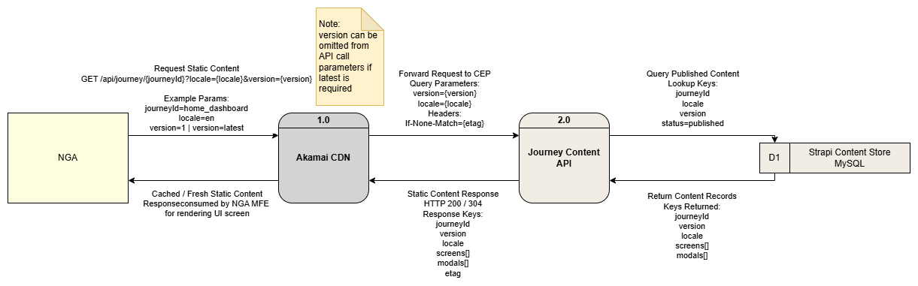

L2
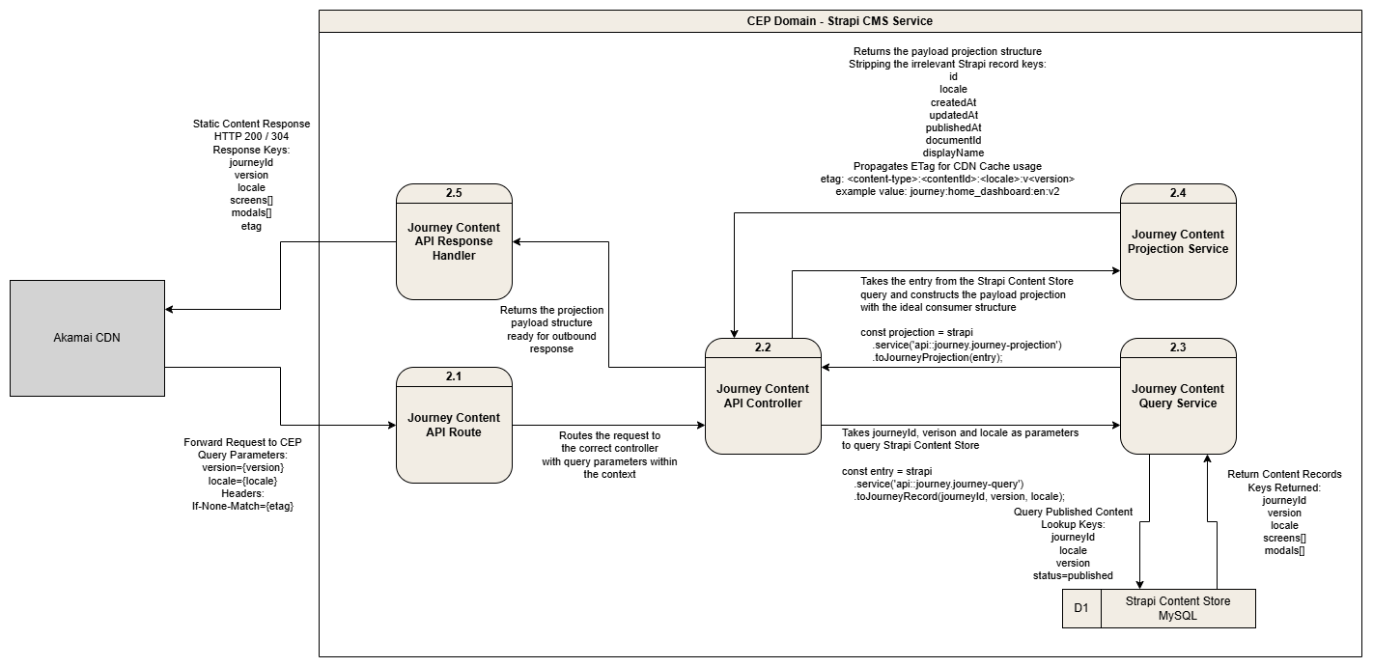

Dynamic Content Data Flow
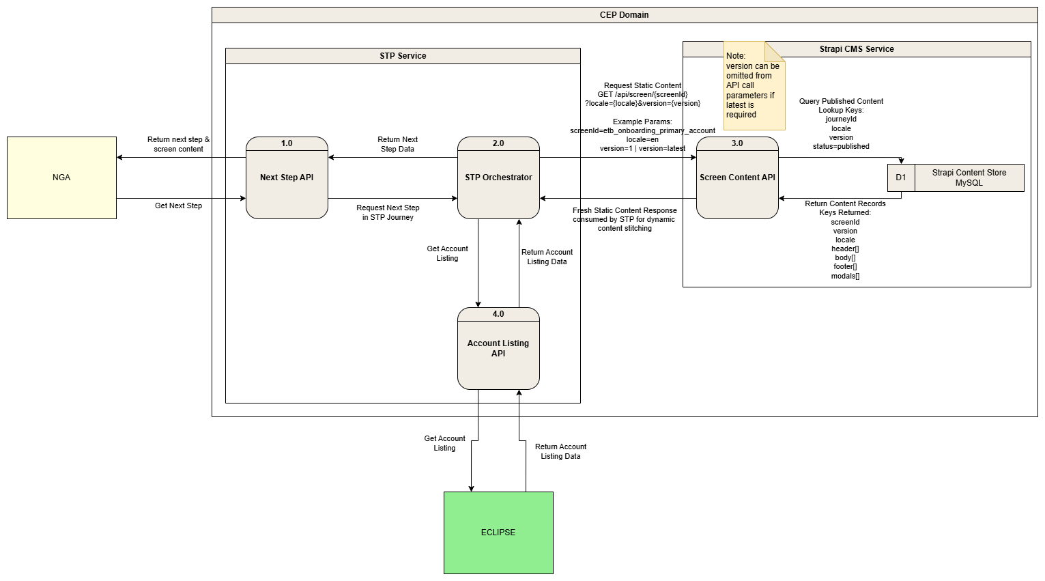

Hybrid Content Data Flow
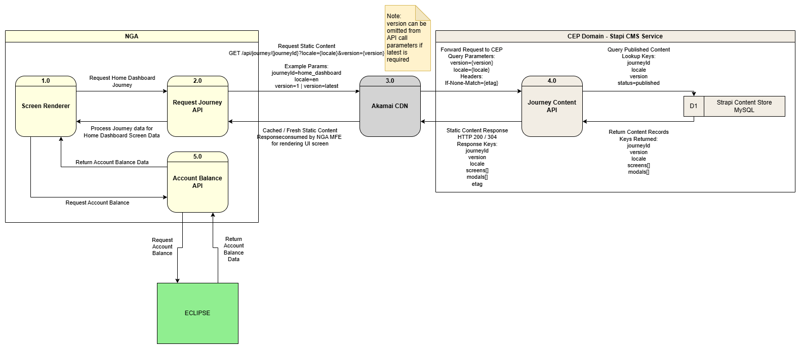

Caching Strategy
Status: the ETag-based validation described below is not yet implemented. There is no ETag, If-None-Match or Cache-Control handling in the CMS codebase today, and no manifest endpoint (section 3.1.5). The publish-webhook invalidation path described at the end of this section is implemented and in use. Diagrams remain to be added.
The CMS caching strategy is designed to improve content delivery performance, reduce repeated load on Strapi and ensure consumers receive consistent published content. Caching will be applied differently depending on the consuming channel, with frontend-facing requests using CDN-based caching and backend service consumers using internal service-level caching.
Frontend-facing CMS APIs consumed by NGA MFEs will be routed through Akamai CDN. Published content responses should include cache-friendly headers such as ETag and Cache-Control, allowing the mobile application and CDN to determine whether content has changed before downloading the full payload again. The ETag value should be generated based on the content identifier, locale, version and last published timestamp so that changes to published content result in a new cache validator.
Backend services such as STP or MBPNS should call Strapi internally within the CEP domain and should not route through Akamai. These services may maintain their own cache, such as Hazelcast, for frequently accessed CMS content including screen records, journey configurations, notification templates, and receipt templates. Cached records should be stored using stable cache keys based on content type, content ID, locale and version, for example:
- screen:SCR_CC_EKTP:en:v3
- navigator:APPLY_CC:en
- notification-template:3f2a7c14-9e5b-4d81:en:v5
When content is published or updated in Strapi, a publish webhook should notify the relevant consuming services so that their internal cache can be refreshed or invalidated. This ensures backend services do not continue serving stale content after a new approved version has been published.
This webhook is implemented, and its payload contract is specified in section 3.1.6. Because the payload carries only a hash of the record rather than the record itself, a consumer must treat it as an invalidation signal and re-read the content through the delivery API. Note also that the de-duplication guards described in section 3.1.6 are in-process, so a consumer must not assume exactly-once delivery when the CMS runs more than one instance.
The caching approach should follow the principle that Strapi remains the source of truth, while Akamai, application caches and backend service caches act only as delivery optimisation layers. Consumers should always be able to revalidate cached content against the CMS using version, locale and ETag-based checks. Published content should be treated as immutable for a given version, with new content changes resulting in a new versioned record where required.

Appendix

Glossary of Terms
Term | Description
Akamai | CDN platform used to cache and deliver frontend-facing CMS content
API | Application Programming Interface
CDN | Content Delivery Network
CEP | Customer Engagement Platform
CMS | Content Management System
Content Type | A Strapi data model used to define a structured type of content
Collection Type | A Strapi content type that can contain multiple records
Component | A reusable Strapi content structure embedded inside content types. Not used in the current CEP CMS content model - the component layer was removed and every such field is now plain JSON.
Custom Field | A Strapi field type registered by the application that stores a standard primitive value but renders a bespoke input in the admin panel.
DDD | Detailed Design Document
Dynamic Zone | A Strapi field that allows different component types to be configured flexibly within the same area. Not used in the current CEP CMS content model.
ECLIPSE | Enterprise Customer Lifestyle Information Processing Service Engine
ETag | Entity Tag used for cache validation to determine whether content has changed
Hazelcast | Distributed caching platform used by backend services to store frequently accessed CMS content
i18n | Internationalisation; handling multiple languages and locales
ID | Identifier
Locale | Language or regional variation of content, such as en, ms or id
JSON | JavaScript Object Notation
MBPNS | Maybank Platform Notification Suite
MDIP | Maybank Digital Identity Platform
MFE | Micro Frontend
Module | A logical grouping of screens in NGA (e.g. Settings, Tabung, Money Out). Referenced through the moduleId field; there is no module collection type in the CMS.
MySQL | Relational database used by Strapi to store CMS records
NGA | NextGen Mobile Application
Payload | Request or response body exchanged through an API
PII | Personally Identifiable Information
P&T | Payment & Transfers (Domain)
QA | Quality Assurance
RBAC | Role-Based Access Control
REST | Representational State Transfer; common API style using HTTP methods such as GET and POST
SLA | Service Level Agreement
SOP | Standard Operating Procedure
Single Type | A Strapi content type that holds exactly one record (one per locale when localised), as opposed to a Collection Type.
SQL | Structured Query Language
STP | Straight-Through-Processing
Strapi | Headless CMS platform used to manage and deliver structured content
UI | User Interface
URL | Uniform Resource Locator
UUID | Universally Unique Identifier; the v4 form is randomly generated and is used for notification-template templateId values.
Webhook | Event-based callback triggered by Strapi when content is published or changed

